Table Configuration
Shows the columns/fields of the Network Request table and their data types.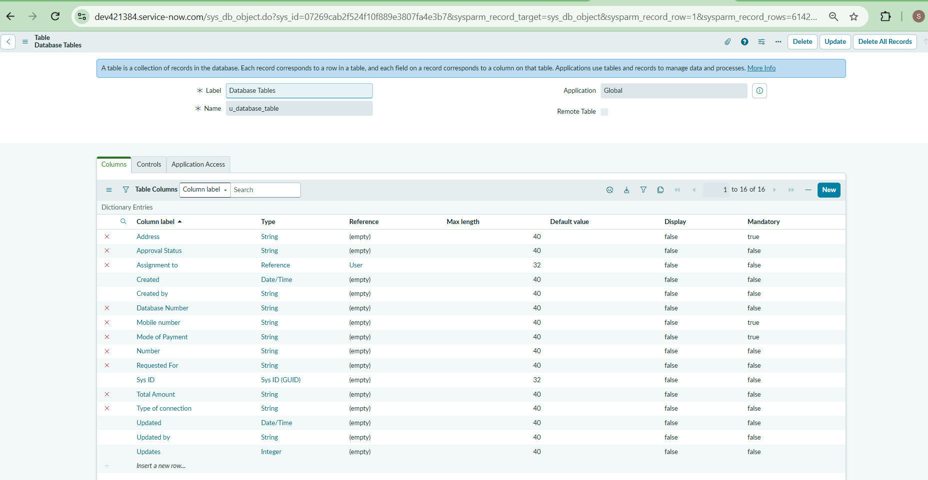

Relationship Configuration
Shows a relationship between tables and uses a script to find related records.
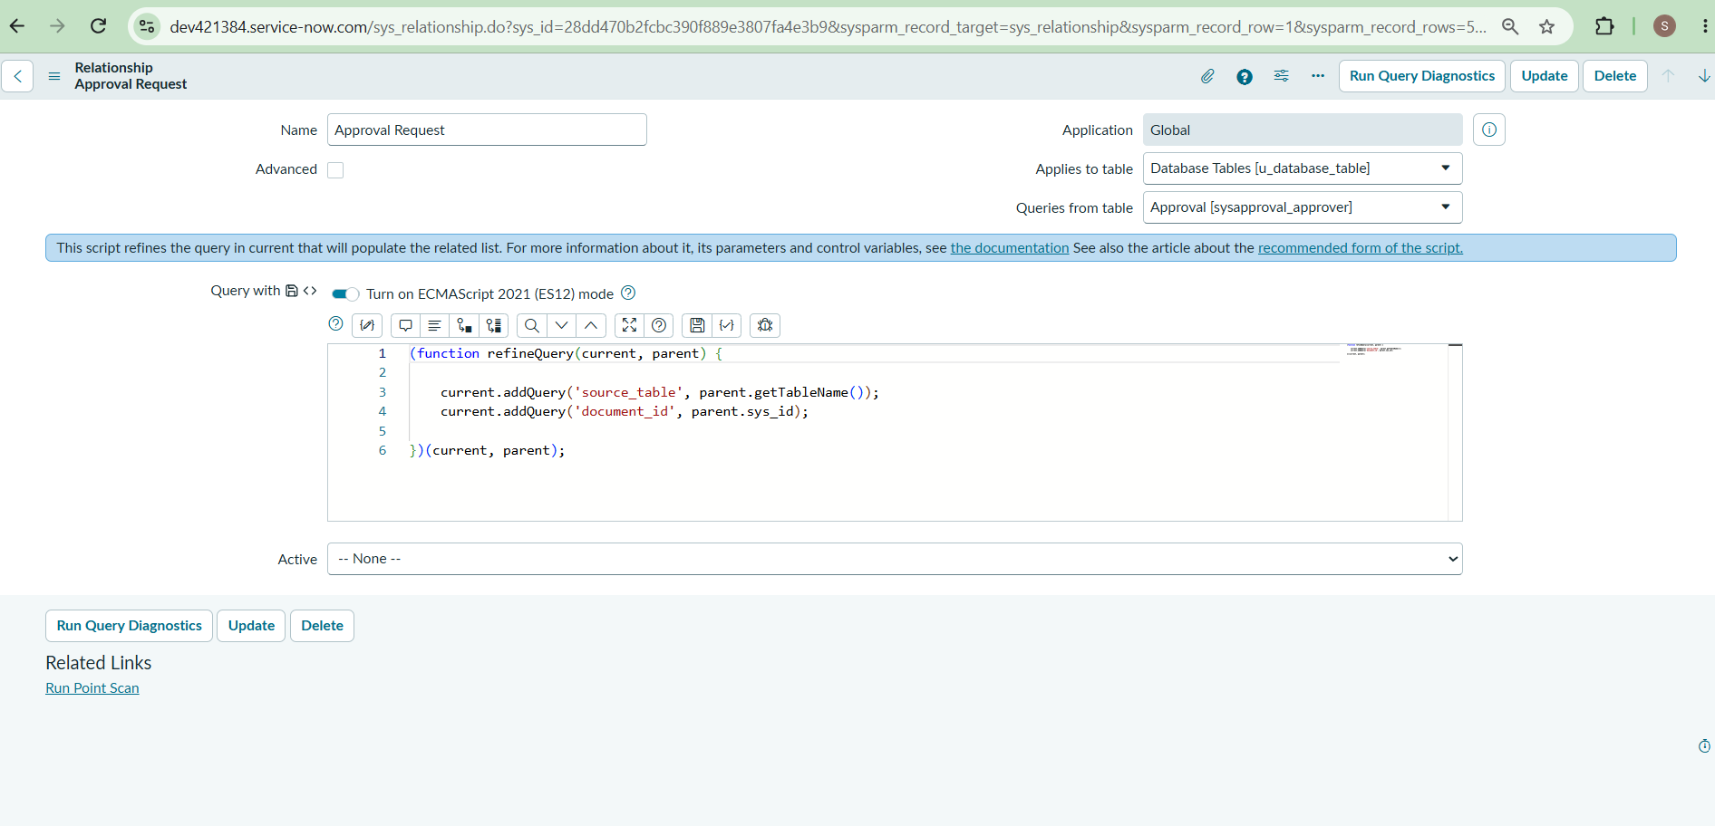

Catalog Item Creation
Shows the creation of a Network Request catalog item in ServiceNow.

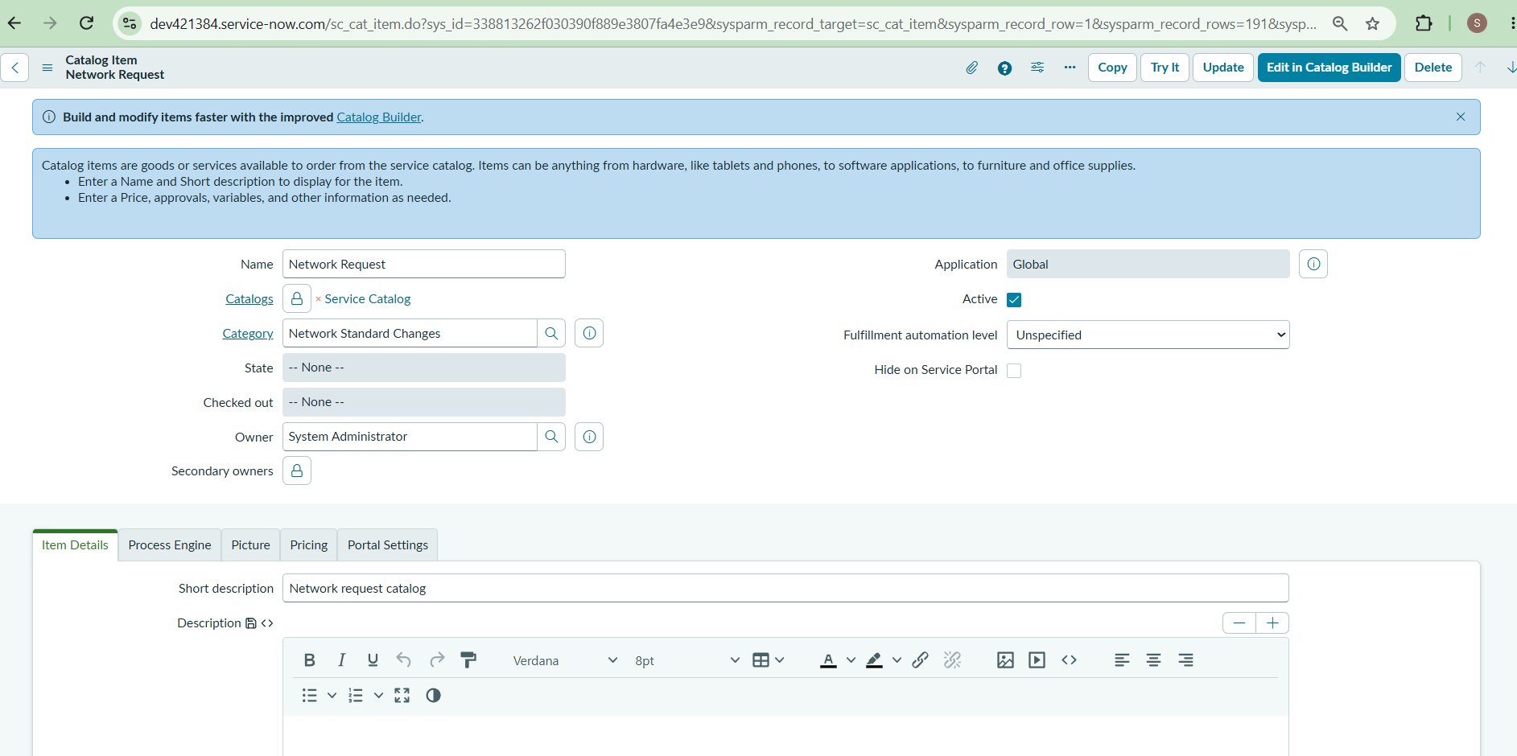

Catalog Variables
Shows the questions/variables added to the Network Request form, such as name, mobile number, amount, and address.
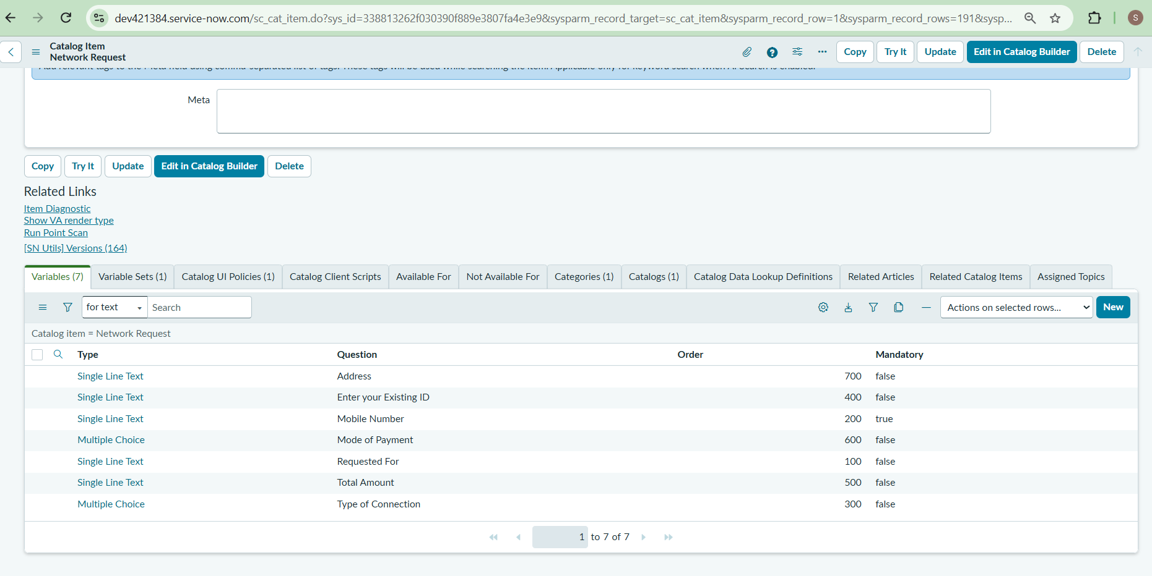

Service Portal
Shows the ServiceNow portal where the user searches for and selects the Network Request.
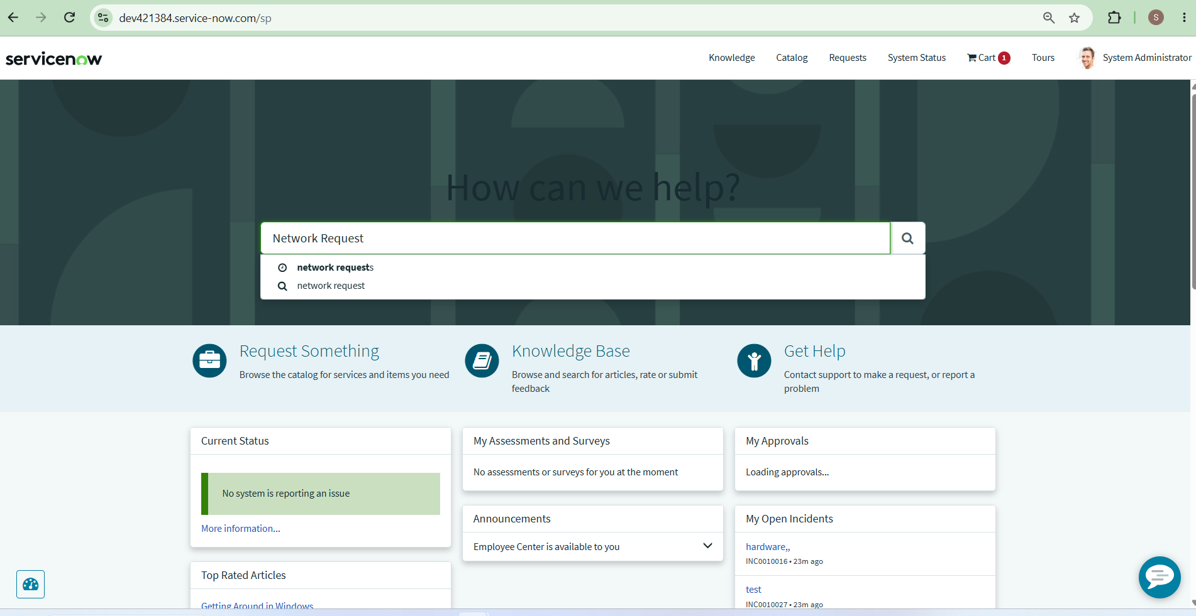

Request Form
Shows the Network Request form where the user enters the required information and submits the request.

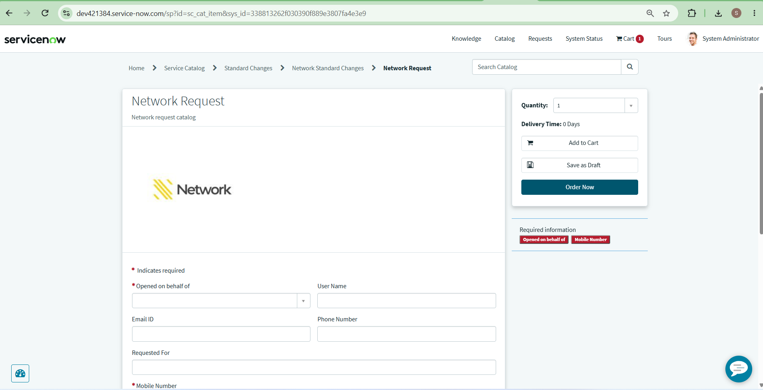

Form Fields
Shows more fields of the Network Request form, where the user provides connection, payment, amount, and address details.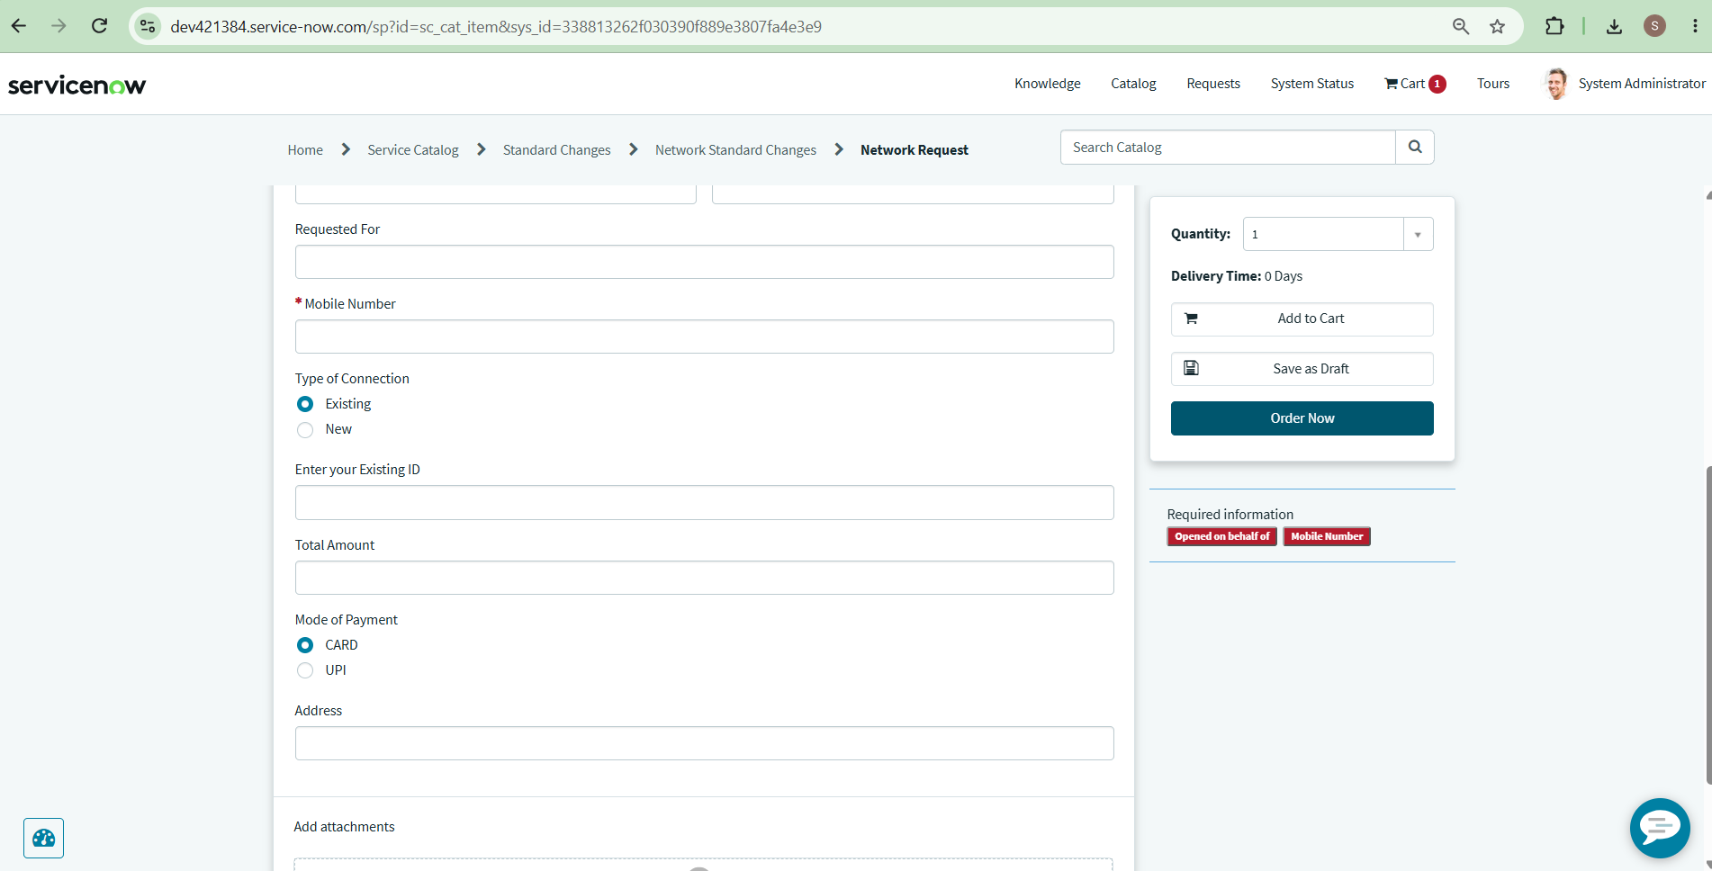
Flow Designer
Shows the workflow/automation: create a database record, send emails, ask for approval, and update the record based on approval.

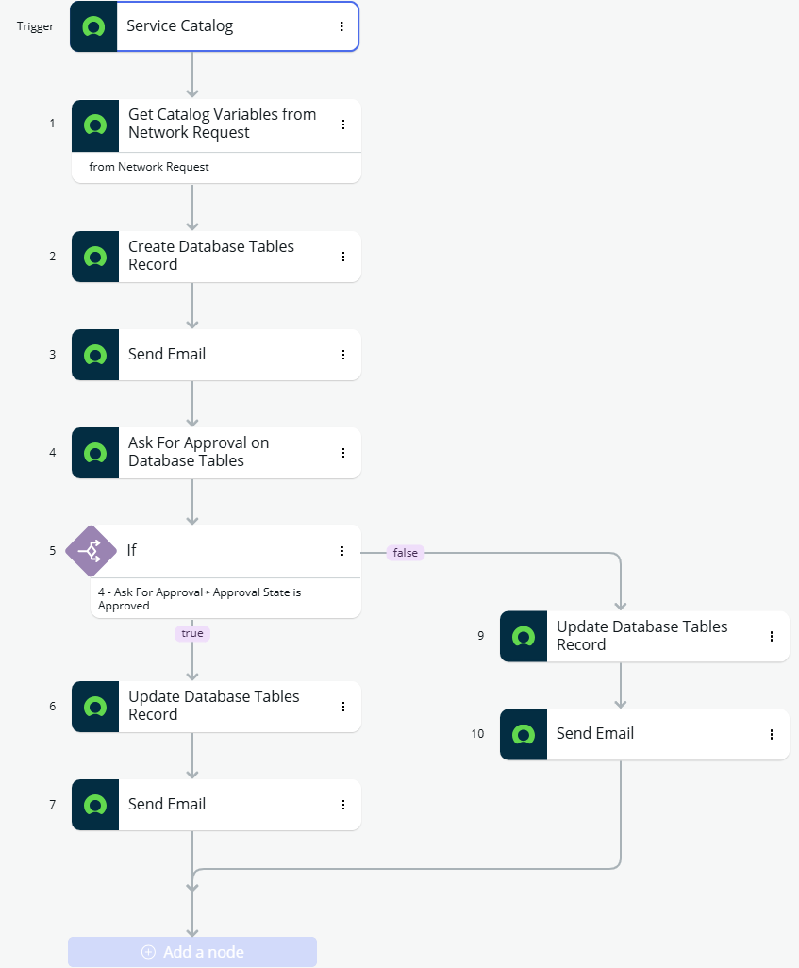

Database Records
Shows the submitted Network Request records stored in the database/table.
